RuleDrlGenerator
Recursive Condition Tree → Drools DRL
Developer Handover & Implementation Guide
Rule Engine Library · leads.ruleengine.core
Package: service / dto · Component: RuleDrlGenerator
Audience: an engineer taking over this library. Read top to bottom once; after that use the
table of contents as a reference.

Contents
1. What this class does
2. The condition tree model
3. Worked example (end to end)
4. How generation works
5. Leaf rendering & the catalog
6. The otherwise branch & De-Morgan
7. Guards & error handling
8. Database-driven inputs
9. Full annotated source
10. How to extend it
11. Validation evidence
12. Migration note (flat → tree)

1. What this class does
A business user builds a rule in the Visual Rule Builder by dragging conditions together. The UI saves that rule as JSON in the RULE_DEFINITION.SOURCE_JSON column. The rule engine, however, only ever runs Drools DRL. RuleDrlGenerator is the one place that turns the builder's JSON into executable DRL text.
It is a stateless Spring @Component. It is called at two moments: when an admin saves or previews a rule, and (indirectly, via the stored DRL_TEXT) whenever the engine rebuilds its rule base. It never runs at request time — by the time a transaction is validated, the DRL is already compiled and sitting in the KieSession.
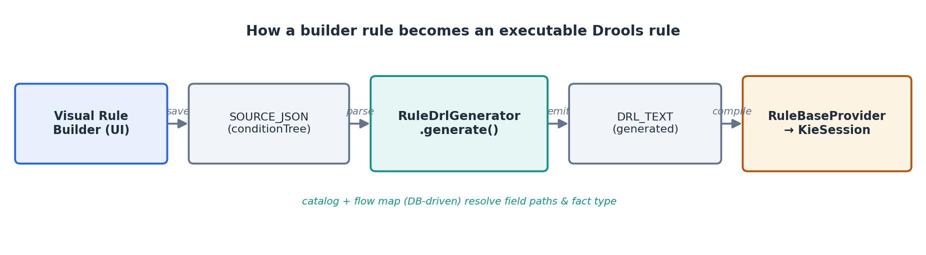
Figure 1 — Where RuleDrlGenerator sits in the pipeline.
Two facts make the generator fully database-driven, so the same code serves every flow without change:
- REQUEST_FLOW_MAP gives the fully-qualified fact type (the Java class the rule matches) for the rule's flow.
- RULE_FIELD_CATALOG gives, for each field key, its real drlPath (e.g. transaction.amount) and its dataType (NUMBER / ENUM / STRING / BOOLEAN), which decides quoting.

2. The condition tree model
The old model was a flat list of conditions joined by a single match: all|any — it could only express "all of these" or "any of these", never a mix. That has been replaced by a recursive tree (an AST), so a rule can nest AND and OR to any depth.
Three small types model the tree. They live in the dto package:
Type | JSON "type" | Role
ConditionNode | — | Interface (Jackson polymorphic base). The open abstraction that lets a tree hold both leaves and groups.
ConditionGroup | GROUP | A branch: an operator (AND / OR) plus a list of child nodes. Children may be leaves or further groups.
ConditionLeaf | CONDITION | A leaf: one field comparison — field, operator, and either a literal value or a valueField (field-to-field compare).

Jackson decides which class to build from the "type" discriminator on each node, declared once on the interface:
@JsonTypeInfo(use = JsonTypeInfo.Id.NAME, property = "type")
@JsonSubTypes({
@JsonSubTypes.Type(value = ConditionGroup.class, name = "GROUP"),
@JsonSubTypes.Type(value = ConditionLeaf.class, name = "CONDITION")
})
public interface ConditionNode {}

The JSON a rule is saved as
{
"ruleName": "Block high-value cross-border non-BDT transfer",
"flow": "TRANSFER_TRANSACTION",
"agendaGroup": "COMPLIANCE",
"salience": 20,
"conditionTree": {
"type": "GROUP", "operator": "AND",
"children": [
{ "type":"CONDITION", "field":"transaction.currency", "operator":"!=", "value":"BDT" },
{ "type":"CONDITION", "field":"transaction.amount", "operator":">=", "value":100000 },
{ "type":"CONDITION", "field":"transaction.country", "operator":"==", "value":"OTHER" }
]
},
"then": { "decision": "block", "message": "Blocked: needs manual review" },
"otherwise": { "decision": "allow" }
}
A single-level AND rule. Swap a child for another GROUP and the tree nests — see §3.

3. Worked example (end to end)
Take the deepest shape the team tests: (((A OR B) AND C) OR D) AND (E OR (F AND G)). As a tree it looks like this:
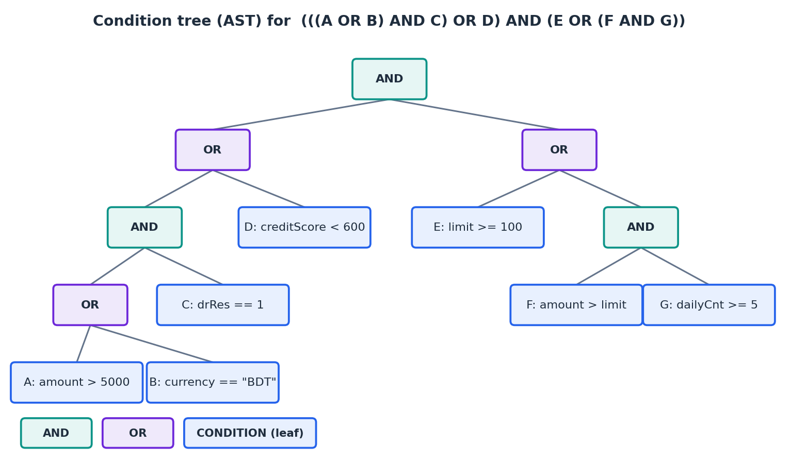
Figure 2 — The condition tree. Teal = AND, purple = OR, blue = leaf (one comparison).
The generator walks this tree once and emits a single Drools pattern. Each group becomes a parenthesised sub-expression; children are joined with && (AND) or || (OR). The result:
rule "Complex nested rule"
agenda-group "COMPLIANCE"
salience 20
when
$ctx : com.example.droolspoc.model.ValidationContext(
((((transaction.amount > 5000 || transaction.currency == "BDT") && product.drRes == 1)
|| customer.creditScore < 600)
&& (userLimit.limit >= 100
|| (transaction.amount > userLimit.limit && transaction.dailyTxnCount >= 5)))
)
then
$ctx.setValid(false);
$ctx.setPermissionDenied(true);
$ctx.setValidationMessage("Blocked: complex condition met");
end
One rule, one pattern, one boolean expression. This is the idiomatic Drools approach — the alternative (one pattern per condition) would change the meaning and defeat the engine's node sharing.

4. How generation works
The entry point is generate(BuilderRuleSpec). It resolves the fact type, walks the tree to build the main pattern, and — if an otherwise branch exists — walks it again in negated mode to emit a second rule.
public String generate(BuilderRuleSpec spec) {
if (spec.conditionTree == null)
throw new RuleCompilationException("Rule '" + spec.ruleName + "' has no condition tree.");
String factFqn = resolveFactType(spec); // from REQUEST_FLOW_MAP
String pkg = factFqn.substring(0, factFqn.lastIndexOf('.'));

StringBuilder sb = new StringBuilder("package " + pkg + ";\n\n");
sb.append(ruleBlock(spec.ruleName, spec, factFqn,
generateNode(spec.conditionTree, false, 0), spec.then)); // main
if (spec.otherwise != null && spec.otherwise.decision != null) {
sb.append("\n\n").append(ruleBlock(spec.ruleName + " - otherwise", spec, factFqn,
generateNode(spec.conditionTree, true, 0), spec.otherwise)); // negated
}
return sb.toString();
}
The heart is generateNode — a classic recursive AST walk. It dispatches on the node kind and passes negate and depth down the tree.
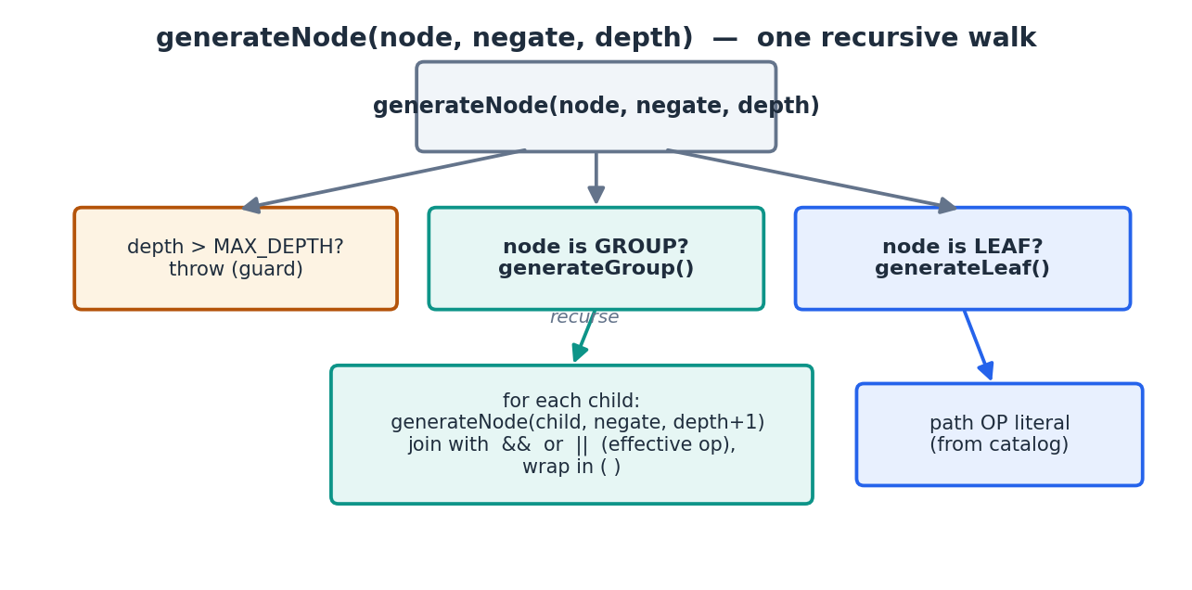
Figure 3 — generateNode dispatches to a leaf or a group; a group recurses into its children.
private String generateNode(ConditionNode node, boolean negate, int depth) {
if (node == null) throw new RuleCompilationException("Condition node cannot be null.");
if (depth > MAX_DEPTH) throw new RuleCompilationException("Condition tree is nested too deep (max " + MAX_DEPTH + ").");
if (node instanceof ConditionLeaf leaf) return generateLeaf(leaf, negate);
if (node instanceof ConditionGroup group) return generateGroup(group, negate, depth);
throw new RuleCompilationException("Unsupported condition node: " + node.getClass().getName());
}

A group: join children, wrap in parentheses
private String generateGroup(ConditionGroup group, boolean negate, int depth) {
if (group.children == null || group.children.isEmpty())
throw new RuleCompilationException("A condition group cannot be empty.");
String op = group.operator == null ? "AND" : group.operator.trim().toUpperCase();
if (!op.equals("AND") && !op.equals("OR"))
throw new RuleCompilationException("Group operator must be AND or OR, got: " + group.operator);

// De-Morgan: NOT(a AND b) = (!a OR !b) ; NOT(a OR b) = (!a AND !b)
String effective = negate ? (op.equals("AND") ? "OR" : "AND") : op;

List<String> parts = new ArrayList<>();
for (ConditionNode child : group.children)
parts.add(generateNode(child, negate, depth + 1)); // <-- recursion

String joiner = effective.equals("AND") ? " && " : " || ";
return "(" + String.join(joiner, parts) + ")";
}
Every group is wrapped in its own ( ). That is what makes nesting unambiguous: the parentheses in the output mirror the shape of the tree exactly, so operator precedence can never surprise you.

5. Leaf rendering & the catalog
A leaf becomes path operator literal. The path and data type come from RULE_FIELD_CATALOG (looked up by the leaf's field key); the literal is formatted according to the data type.
private String generateLeaf(ConditionLeaf c, boolean negate) {
if (c.field == null || c.field.isBlank())
throw new RuleCompilationException("A condition is missing its field.");
Optional<RuleFieldCatalog> field = catalogRepository.findFirstByFieldKey(c.field);
String drlPath = field.map(RuleFieldCatalog::getDrlPath).orElse(c.field);
String dataType = field.map(RuleFieldCatalog::getDataType).orElse("NUMBER").toUpperCase();
String op = negate ? negateOperator(c.operator) : c.operator;
return drlPath + " " + op + " " + literal(c, dataType);
}

private String literal(ConditionLeaf c, String dataType) {
if (c.valueField != null && !c.valueField.isBlank()) // field-to-field compare
return catalogRepository.findFirstByFieldKey(c.valueField)
.map(RuleFieldCatalog::getDrlPath).orElse(c.valueField);
if ("ENUM".equals(dataType) || "STRING".equals(dataType)) // quote + escape
return "\"" + String.valueOf(c.value).replace("\\","\\\\").replace("\"","\\\"") + "\"";
return String.valueOf(c.value); // number / boolean raw
}
Leaf input | dataType | DRL output
field=transaction.amount, op=">", value=5000 | NUMBER | transaction.amount > 5000
field=transaction.currency, op="==", value=BDT | ENUM | transaction.currency == "BDT"
field=transaction.amount, op=">", valueField=userLimit.limit | (any) | transaction.amount > userLimit.limit

Note the last row: when valueField is set, the right-hand side is another field's path (never quoted), so the rule compares two fields.

6. The otherwise branch & De-Morgan
An optional otherwise outcome emits a second rule that fires exactly when the first does not. Rather than wrapping the whole thing in a Drools not(), the generator pushes the negation down through the tree using De-Morgan's laws — flipping every group's operator and negating every leaf's comparison.
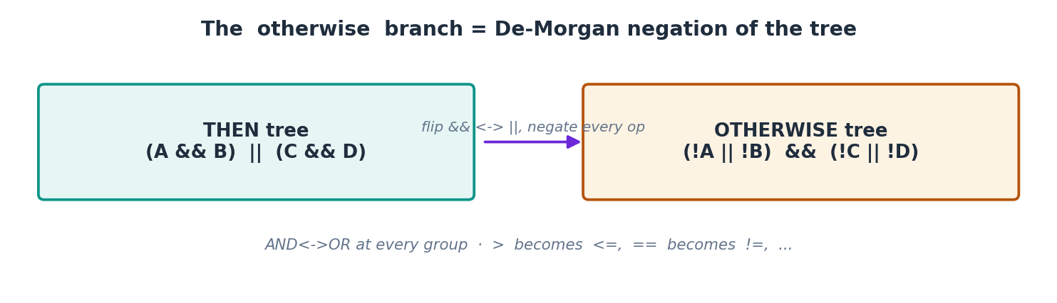
Figure 4 — otherwise is the De-Morgan negation: AND↔OR at every group, every operator flipped.
The operator flips used by negateOperator:
Operator | Negated | Operator | Negated
> | <= | == | !=
< | >= | != | ==
>= | < | > | —

An unknown operator is not silently passed through — negateOperator throws, because a wrong negation would be a silent correctness bug (the else-rule would allow things it should block).

7. Guards & error handling
The generator fails loudly and early. Every throw produces a clear message and prevents bad DRL from ever reaching the compiler:
Guard | Why
conditionTree == null | A rule with no conditions is meaningless; reject at the entry point.
depth > MAX_DEPTH (10) | Guards against pathological or malicious input that could blow the stack.
empty group | An AND/OR with no children has no meaning.
operator not AND/OR | Only these two group operators are supported.
unknown comparison op | Cannot be safely negated — see §6.
missing field | A leaf must name a field.
no fact type for flow | Can't build a pattern without the Java class to match; points the developer to REQUEST_FLOW_MAP.

8. Database-driven inputs
The generator reads two tables so the same code works for every flow. Neither is hard-coded.

REQUEST_FLOW_MAP — the fact type
private String resolveFactType(BuilderRuleSpec spec) {
if (spec.flow == null || spec.flow.isBlank())
throw new RuleCompilationException("Builder rule '" + spec.ruleName + "' has no flow.");
return requestFlowMapRepository.findFirstByFlowName(spec.flow)
.map(RequestFlowMap::getFactType)
.orElseThrow(() -> new RuleCompilationException(
"No fact type for flow '" + spec.flow + "'. Set FACT_TYPE on the REQUEST_FLOW_MAP row."));
}
For TRANSFER_TRANSACTION this returns com.example.droolspoc.model.ValidationContext — the $ctx the pattern matches, and the package the generated DRL is declared in.

RULE_FIELD_CATALOG — paths & types
Each field the builder offers has a catalog row: the field_key the UI uses, the drl_path the engine needs, and the data_type that drives quoting. This is why the generator never hard-codes a field name or a type.

9. Full annotated source
The complete class, as shipped. Everything above is a guided tour of this file.
package leads.ruleengine.core.service;

import com.fasterxml.jackson.databind.ObjectMapper;
import leads.ruleengine.core.dto.BuilderRuleSpec;
import leads.ruleengine.core.dto.ConditionGroup;
import leads.ruleengine.core.dto.ConditionLeaf;
import leads.ruleengine.core.dto.ConditionNode;
import leads.ruleengine.core.exception.RuleCompilationException;
import leads.ruleengine.core.model.RequestFlowMap;
import leads.ruleengine.core.model.RuleFieldCatalog;
import leads.ruleengine.core.repository.RequestFlowMapRepository;
import leads.ruleengine.core.repository.RuleFieldCatalogRepository;
import org.springframework.stereotype.Component;

import java.util.ArrayList;
import java.util.List;
import java.util.Optional;

/**
* Turns a Visual Rule Builder spec (SOURCE_JSON) into executable DRL (DRL_TEXT).
*
* Condition tree. The spec carries a recursive ConditionNode tree, so a rule can
* nest AND/OR to any depth - e.g. (A AND B) OR (C AND D). The generator walks the
* tree recursively, wrapping every group in parentheses and joining children with && / ||.
*
* Fully DB-driven. Each leaf's real path and data type come from RULE_FIELD_CATALOG;
* the fact/context type the rule matches comes from REQUEST_FLOW_MAP.FACT_TYPE for the flow.
*
* IF / ELSE. An optional otherwise branch emits a second rule whose tree is the
* De-Morgan negation of the first: every group flips AND<->OR and every leaf operator is negated.
*
* @author K M Farhat Snigdah
*/
@Component
public class RuleDrlGenerator {

/** Guard against pathological input: the tree may not nest deeper than this. */
private static final int MAX_DEPTH = 10;

private final RequestFlowMapRepository requestFlowMapRepository;
private final RuleFieldCatalogRepository catalogRepository;
private final ObjectMapper objectMapper = new ObjectMapper();

public RuleDrlGenerator(RequestFlowMapRepository requestFlowMapRepository,
RuleFieldCatalogRepository catalogRepository) {
this.requestFlowMapRepository = requestFlowMapRepository;
this.catalogRepository = catalogRepository;
}

/** Parse the builder JSON and generate DRL. */
public String fromJson(String sourceJson) {
BuilderRuleSpec spec;
try {
spec = objectMapper.readValue(sourceJson, BuilderRuleSpec.class);
} catch (Exception e) {
throw new RuleCompilationException("Invalid builder JSON: " + e.getMessage());
}
return generate(spec);
}

/** Generate DRL from an already-parsed spec. */
public String generate(BuilderRuleSpec spec) {
if (spec.conditionTree == null) {
throw new RuleCompilationException("Rule '" + spec.ruleName + "' has no condition tree.");
}
String factFqn = resolveFactType(spec);
String pkg = factFqn.contains(".") ? factFqn.substring(0, factFqn.lastIndexOf('.')) : "rules";

StringBuilder sb = new StringBuilder();
sb.append("package ").append(pkg).append(";\n\n");
sb.append(ruleBlock(spec.ruleName, spec, factFqn,
generateNode(spec.conditionTree, false, 0), spec.then));
if (spec.otherwise != null && spec.otherwise.decision != null) {
sb.append("\n\n");
sb.append(ruleBlock(spec.ruleName + " - otherwise", spec, factFqn,
generateNode(spec.conditionTree, true, 0), spec.otherwise));
}
return sb.toString();
}

/** Fact/context type for the rule's flow, from REQUEST_FLOW_MAP.fact_type - DB-driven. */
private String resolveFactType(BuilderRuleSpec spec) {
if (spec.flow == null || spec.flow.isBlank()) {
throw new RuleCompilationException("Builder rule '" + spec.ruleName + "' has no flow.");
}
String factFqn = requestFlowMapRepository.findFirstByFlowName(spec.flow)
.map(RequestFlowMap::getFactType)
.orElse(null);
if (factFqn == null || factFqn.isBlank()) {
throw new RuleCompilationException(
"No fact type for flow '" + spec.flow + "'. Set FACT_TYPE on the REQUEST_FLOW_MAP row "
+ "for that flow (or POST /admin/flows/mappings with factType).");
}
return factFqn;
}

private String ruleBlock(String name, BuilderRuleSpec spec, String factFqn, String pattern,
BuilderRuleSpec.Outcome outcome) {
int salience = spec.salience == null ? 0 : spec.salience;
return "rule \"" + name + "\"\n"
+ " agenda-group \"" + spec.agendaGroup + "\"\n"
+ " salience " + salience + "\n"
+ " when\n"
+ " $ctx : " + factFqn + "(\n"
+ " " + pattern + "\n"
+ " )\n"
+ " then\n"
+ thenBody(outcome) + "\n"
+ "end";
}

// ---- recursive tree walk -------------------------------------------------------------

/** Render any node to a DRL boolean expression. negate applies De-Morgan on the way down. */
private String generateNode(ConditionNode node, boolean negate, int depth) {
if (node == null) {
throw new RuleCompilationException("Condition node cannot be null.");
}
if (depth > MAX_DEPTH) {
throw new RuleCompilationException("Condition tree is nested too deep (max " + MAX_DEPTH + ").");
}
if (node instanceof ConditionLeaf leaf) {
return generateLeaf(leaf, negate);
}
if (node instanceof ConditionGroup group) {
return generateGroup(group, negate, depth);
}
throw new RuleCompilationException("Unsupported condition node: " + node.getClass().getName());
}

private String generateGroup(ConditionGroup group, boolean negate, int depth) {
if (group.children == null || group.children.isEmpty()) {
throw new RuleCompilationException("A condition group cannot be empty.");
}
String op = group.operator == null ? "AND" : group.operator.trim().toUpperCase();
if (!op.equals("AND") && !op.equals("OR")) {
throw new RuleCompilationException("Group operator must be AND or OR, got: " + group.operator);
}
// De Morgan: NOT(a AND b) = (!a OR !b) ; NOT(a OR b) = (!a AND !b)
String effective = negate ? (op.equals("AND") ? "OR" : "AND") : op;

List<String> parts = new ArrayList<>();
for (ConditionNode child : group.children) {
parts.add(generateNode(child, negate, depth + 1));
}
String joiner = effective.equals("AND") ? " && " : " || ";
return "(" + String.join(joiner, parts) + ")";
}

private String generateLeaf(ConditionLeaf c, boolean negate) {
if (c.field == null || c.field.isBlank()) {
throw new RuleCompilationException("A condition is missing its field.");
}
Optional<RuleFieldCatalog> field = catalogRepository.findFirstByFieldKey(c.field);
String drlPath = field.map(RuleFieldCatalog::getDrlPath).orElse(c.field);
String dataType = field.map(RuleFieldCatalog::getDataType).orElse("NUMBER").toUpperCase();
String op = negate ? negateOperator(c.operator) : c.operator;
return drlPath + " " + op + " " + literal(c, dataType);
}

private String literal(ConditionLeaf c, String dataType) {
if (c.valueField != null && !c.valueField.isBlank()) {
return catalogRepository.findFirstByFieldKey(c.valueField)
.map(RuleFieldCatalog::getDrlPath).orElse(c.valueField);
}
if ("ENUM".equals(dataType) || "STRING".equals(dataType)) {
return "\"" + String.valueOf(c.value).replace("\\", "\\\\").replace("\"", "\\\"") + "\"";
}
return String.valueOf(c.value);
}

/** Opposite comparison. Fails loudly on an unknown operator (better than silent bad DRL). */
private String negateOperator(String operator) {
if (operator == null) {
throw new RuleCompilationException("A condition is missing its operator.");
}
return switch (operator) {
case ">" -> "<=";
case "<" -> ">=";
case ">=" -> "<";
case "<=" -> ">";
case "==" -> "!=";
case "!=" -> "==";
default -> throw new RuleCompilationException("Cannot negate operator: " + operator);
};
}

private String thenBody(BuilderRuleSpec.Outcome outcome) {
String decision = (outcome == null || outcome.decision == null) ? "block" : outcome.decision.toLowerCase();
StringBuilder b = new StringBuilder();
if ("allow".equals(decision)) {
b.append(" $ctx.setValid(true);");
} else {
b.append(" $ctx.setValid(false);\n");
b.append(" $ctx.setPermissionDenied(true);");
}
if (outcome != null && outcome.message != null && !outcome.message.isBlank()) {
b.append("\n $ctx.setValidationMessage(\"").append(escape(outcome.message)).append("\");");
}
return b.toString();
}

private String escape(String s) {
return s.replace("\\", "\\\\").replace("\"", "\\\"");
}
}

10. How to extend it
The tree abstraction was kept deliberately open so new condition kinds can be added without reshaping anything. To add a new node type — say NOT, IN, or BETWEEN:
- Add a DTO implementing ConditionNode and register it in the @JsonSubTypes list on the interface (one line).
- Add one if (node instanceof NewType ...) branch in generateNode, plus a small generateX() that returns a DRL string.
- Define its negated form (for the otherwise branch). For IN, the negation is not in; for BETWEEN, it is the two bounds inverted and OR-ed.
Nothing else changes — generate(), generateGroup() and the catalog logic stay as they are, because they only ever see ConditionNode.
One optional optimisation (not a bug): generateLeaf and literal each hit the catalog repository once per leaf, so a deep tree makes N lookups — but only at generation time (admin save), never per request. If the catalog grows large, load it into a Map once per generate() call. Until then, leave it simple.

11. Validation evidence
The recursive logic was proven before this document was written. The real generator code was run against the worst-case shape (((A OR B) AND C) OR D) AND (E OR (F AND G)), and its output was fed into a brute-force truth-table check:
- All 128 combinations of the seven leaves (2⁷) were evaluated.
- The generated main predicate matched the intended tree in every case.
- The generated otherwise predicate equalled the exact logical negation in every case (De-Morgan correct).
- Result: 0 mismatches · parentheses balanced · ENUM quoting and field-compare verified.
Note on the live Drools compile: the engine's own RuleBaseProvider compiles every rule at startup (validate-before-swap), so the real Drools 10.2 compile is exercised each time the backend boots with the migrated rules. The seven existing rules were migrated to the tree format and verified to parse and generate correctly.

12. Migration note (flat → tree)
The previous flat model is gone. BuilderRuleSpec no longer has conditions[] or match; it now has conditionTree. All seven seed rules were migrated. The mechanical change for a single-level rule:

Before (flat)
"match": "all",
"conditions": [
{ "field":"transaction.currency", "operator":"!=", "value":"BDT" },
{ "field":"transaction.amount", "operator":">=", "value":100000 }
]

After (tree)
"conditionTree": {
"type":"GROUP", "operator":"AND",
"children": [
{ "type":"CONDITION", "field":"transaction.currency", "operator":"!=", "value":"BDT" },
{ "type":"CONDITION", "field":"transaction.amount", "operator":">=", "value":100000 }
]
}
In words: match:"all" → a GROUP with operator:"AND" ("any" → "OR"); each old condition → a child with "type":"CONDITION". Every leaf field keeps its exact meaning, so the generated DRL for the migrated rules is identical to before (now written as one parenthesised predicate).

